Suitability of premises form

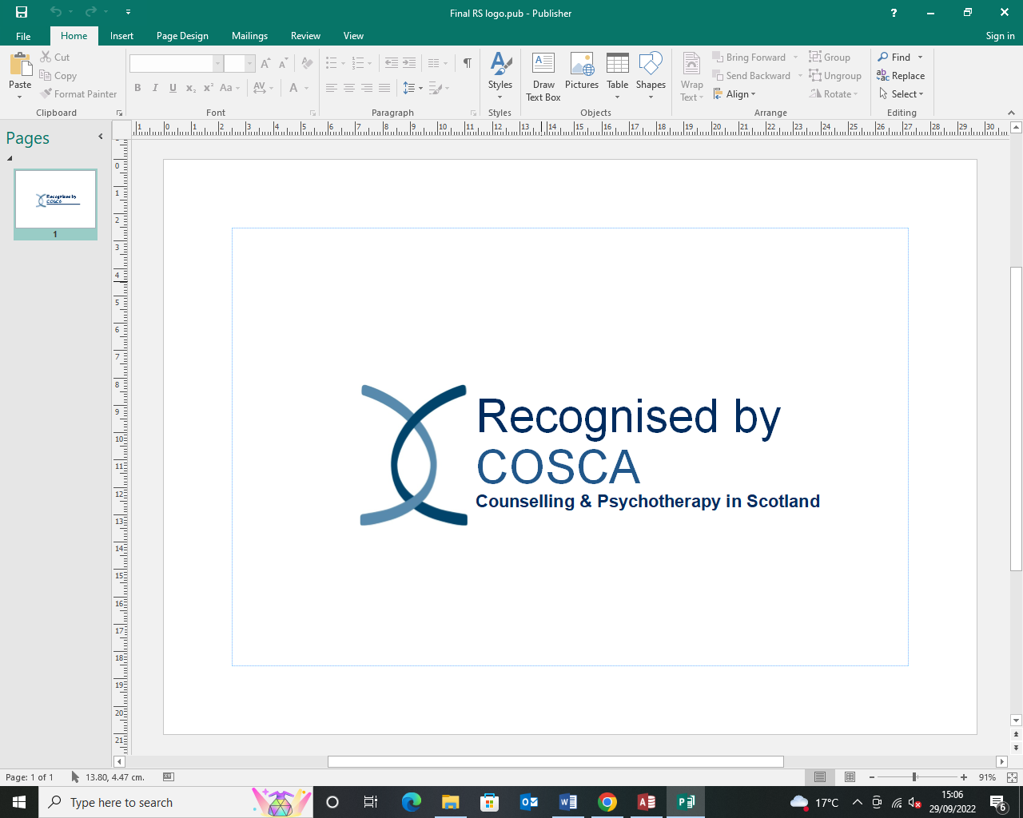

**Registration of Premises**

**Name of COSCA Recognition Scheme Organisation………………………………………………………………….**

**…………………………………………………………………………………………………**

**Address of premises………………………………………………………………………………………………..**

**………………………………………………………………………………………………….**

**1. Introduction**

The premises in which counselling and psychotherapy takes place should be suitable for the establishment and maintenance of a positive and safe therapeutic relationship between the client and the counsellor and/or psychotherapist.

Please state, in the spaces provided, how you meet each of the criteria and return to COSCA within 3 months of official opening or sooner. A separate form is required for each/ any additional premises. This form is not for use when moving premises when a new assessment must be carried out.

##### 2. Location of Premises

|  |  |
| --- | --- |
| 2.1 The premises used for counselling and psychotherapy should be easy and safe for clients to access, and appropriate for the practice of counselling and psychotherapy, including during the hours of darkness. Access to the premises should, if possible, allow clients to arrive and leave without others being aware that they are attending therapy. |  |
| 2.2 Clients are provided with clear directions to and about the premises and are informed about the availability of public transport, car parking spaces, and any other relevant matters, as required. |  |
| 2.3 Further consideration needs to be given to:   * the potential barriers to accessing the premises for disabled people * making reasonable adjustments for clients who have disabilities to access the premises * the availability and suitability of a WC for use by all clients, including those who are disabled * the requirements of the Equality Act (2010) * the management of the arrival and departure of clients that takes account of their privacy and confidentiality |  |

**3. The Therapy Room**

|  |  |
| --- | --- |
| 3.1must be spacious enough to provide comfortable seating for the numbers using it without the risk of the invasion of their personal space. |  |
| 3.2 should be light, informal, comfortable and prove a space in which therapy sessions are inaudible to those outside of the room |  |
| 3.3 must be laid out to give the appearance of being devoted to professional activity. |  |
| 3.4 should conceal audio/visual and other electrical appliances, unless they are being used during the therapy |  |
| 3.5 should not visibly contain personal belongings e.g. counsellor’s coats, bags etc. |  |
| 3.6 should be quiet and private, and during therapy sessions have no interruptions. Telephones, fax machines, pagers, laptops, iPads, PCs, doorbells and any other electronic means of communication should be switched off or made inaudible during sessions with clients. |  |
| 3.7 should not be overlooked in such a way that its occupants are visible to others. |  |

**4. Storage of Client Information**

|  |  |
| --- | --- |
| 4.1 If client information is kept on the premises, it must be securely stored. |  |

**5. Insurance and Legal Use of Premises**

|  |  |
| --- | --- |
| 5.1 any insurance cover that is required for using their premises for counselling and psychotherapy is in place e.g. public liability, accident, professional indemnity etc. |  |
| 5.2 Organisations should ensure that they are permitted under the terms of their ownership, lease or rental of their premises to use the premises for counselling and psychotherapy. |  |

**6. Personal Safety and Care**

|  |  |
| --- | --- |
| 6.1 Personal safety is an important issue in the delivery of counselling and psychotherapy. The Organisation should have in place policies for counsellors that may be open to violent and aggressive behaviour from their clients. Some premises may be more potentially dangerous than others from this kind of behaviour. |  |
| 6.2 There is a health and safety protocol in place. |  |
| 6.3 This protocol should include carrying out an initial risk assessment about whether it is safe for the COSCA registrant to work with clients. The protocol should also outline practical measures to minimise the risk to their personal safety from clients while ensuring that they continue to offer due respect to clients as well as to the task of counselling and psychotherapy. |  |

|  |  |
| --- | --- |
| Signed: | Print Name: |
| Designation: | Date: |

**Please return this form to: Jenna Fraser (Recognition Scheme Development Officer),** [**jenna@cosca.org.uk**](mailto:jenna@cosca.org.uk) **or COSCA, 16 Melville Terrace, Stirling, FK8 2NE**