**COSCA (Counselling & Psychotherapy in Scotland)**

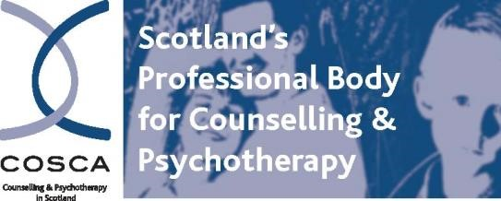

**16 Melville Terrace | Stirling | FK8 2NE**

**t: 01786 475 140 f: 01786 446 207 christina@cosca.org.uk w:**[**www.cosca.org.uk**](http://www.cosca.org.uk/)

**COSCA 25th ANNUAL TRAINERS EVENT**

**Theme:**

# “Resourcing Participants and Trainers’’

**Thursday the 9th of November 2023**

**9:30am – 1:00 pm via ‘Zoom’**

|  |
| --- |
| **WHAT CAN I EXPECT FROM THE EVENT?**    The Trainers Event will be hosted by *Dr Patricia Joyce of ‘Grounded Learning Ltd’.*  The event will explore how trainers can resource themselves and their participants in developing and demonstrating counselling skills and to support self-regulation and conditions of co-regulation in the training room and counselling room.  There will be two interactive workshops delivered, suitable for attendees at all training levels:    **Workshop 1: Facilitator TBC- Developing and Demonstrating Counselling skills**    **Workshop 2: Facilitator TBC- Supporting Self and Co-regulation in the training and counselling room** |
| **WHAT TOPICS WILL BE EXPLORED:**   * The ways in which trainers can support their participants to develop and demonstrate counselling skills, within the counselling approach or relationship. * How trainers may utilise themselves as a resource to model the counselling skills approach with their participants. * The ways in which trainers may identify their participants and their own self-regulatory skills. * How to support conditions of safety and co-regulation in the training and counselling room * The ways in which we may resource ourselves as trainers to support our own self-regulation |

COSCA reserves the right to amend or change the programme accordingly.

|  |
| --- |
| **COST**    **COSCA Members:** **Early Bird Booking** until 31st June 2023: **£25**  1st July 2023 onwards: **£30**    **Non – COSCA Members**: Please **add £10** to the above prices. |

**COSCA (Counselling & Psychotherapy in Scotland)**

**16 Melville Terrace | Stirling| FK8 2NE**

**t:: 01786 475140 f: 01786 446 207**

**e: christina@cosca.org.uk w:** [**www.cosca.org.uk**](http://www.cosca.org.uk/)

## COSCA 25th ANNUAL TRAINERS EVENT

**THURSDAY 9TH November 2023 via ‘Zoom’**

***Please email booking forms to Christina Oliver on:*** [***christina@cosca.org.uk***](mailto:christina@cosca.org.uk)

|  |
| --- |
| Forename Surname Date |
| Mailing Address |
| Town Post Code |
| Telephone  Email |
| Organisations in which you are involved in training and Level of Delivery: |

|  |
| --- |
| **PAYMENT**  **£25 early bird fee / £30 standard fee (non-COSCA members add £10))**  □I have sent a cheque with the fee of £  □ Electronic bank payment (*please use first initial, surname and "Trainers Event" as reference*)  Bank transfer details:  **Bank:** Virgin Bank  **Name:** COSCA (Counselling & Psychotherapy in Scotland)  **Sort code:** 82 68 05  **Account number:** 70174110     * Please invoice **(£2 service charge added)**   **\*\**If your organisation will be paying the invoice, please ensure a Purchase Order is raised and payment is made prior to the event**.*** |

|  |  |  |
| --- | --- | --- |
| **Invoice Address if different from above:** |  |  |
|  | Nominal Code | 7 |
| Invoice/Cheque |  |

Charity Registered in Scotland No. SC018887

Charitable Company Limited by Guarantee Registered in Scotland No. 142360