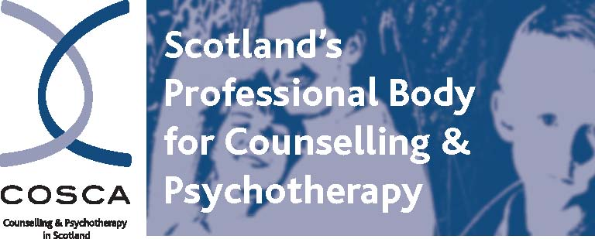
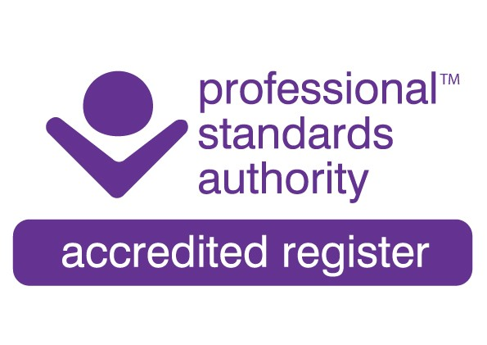

COSCA (Counselling & Psychotherapy in Scotland)
16 Melville Terrace | Stirling | FK8 2NE
t: 01786 475 140 f: 01786 446 207
e: info@cosca.org.uk w: www.cosca.org.uk

COSCA Counsellor and Psychotherapist Accreditation

DIPLOMA ROUTE
APPLICATION

This is the Application for COSCA Counsellor/Psychotherapist Accreditation through the DIPLOMA ROUTE.

Guidelines for the completion of this Application can be found on – www.cosca.org.uk – Accreditation – Counsellor – Diploma Route Guidelines

CONTENTS

APPENDIX A Applicant’s Personal Details, Disclosure
and Declaration

APPENDIX B Submission Checklist
APPENDIX C Practice Log: Summary of Annual Practice
Hours

APPENDIX D Practice Log: Summary of Recent
Period of Work

APPENDIX E Frequency of Client Contact

APPENDIX F Transcript Pro Forma

APPENDIX G Supervision Sessions

APPENDIX H Supervisor’s Report

PAYMENT DETAILS
APPENDIX A: APPLICANT’S PERSONAL DETAILS, DISCLOSURE AND DECLARATION

PART I: Personal Details

Please indicate the date of the Guidelines
to which your application refers. The Guidelines and Application Form used should be the most up to date version. These can be found on the COSCA website: www.cosca.org.uk

Surname
Forename(s)
Address

Post Code
Telephone:

Email:
Practitioner Membership Reference Number:

Have you previously applied for COSCA Counsellor/Psychotherapist Accreditation?
YES NO

If YES, please give date

Counsellor Accreditation Workshops
Please confirm if you have:

Attended the COSCA Counsellor Accreditation System Workshop

Viewed the COSCA Counsellor Accreditation System Online Workshop Video

Office Use
Date Received
Payment

Counselling/Psychotherapy Orientation(s):

APPENDIX A: APPLICANT’S PERSONAL DETAILS, DISCLOSURE AND DECLARATION

Part II: Disclosure

Information given below will not necessarily exclude you from accreditation.

- Have you had membership of any professional counselling/psychotherapy body withdrawn?

YES NO

If “YES”, please give details.

- Do you have any criminal or civil convictions (spent or unspent) or proceedings pending against you?

YES NO

If “YES”, please give details.

- Do you have any professional complaint or disciplinary proceeding brought against you, which was successful or is currently pending?

YES NO

If “YES”, please give details.

- Have you ever been listed as barred under the Protecting Vulnerable Groups Scheme/Disclosure Scotland?

YES NO

- Are you currently listed as barred under the Protecting Vulnerable Groups Scheme/Disclosure Scotland?

YES NO

APPENDIX A: APPLICANT’S PERSONAL DETAILS, DISCLOSURE AND DECLARATION

Part III: Declaration

I declare that:

  - I am applying for COSCA Counsellor/Psychotherapist Accreditation, and agree to abide by COSCA’s Guidelines and Criteria for the Accreditation of Counsellors and Psychotherapists, to be bound by COSCA’s Memorandum and Articles of Association, and to abide by COSCA’s Statement of Ethics and Code of Practice.

  - The evidence I have submitted gives an accurate portrayal of my training, practice, supervision and personal development in counselling.

  - I will inform COSCA of all criminal, civil, complaint or disciplinary proceedings brought against me in the future, which are relevant to my involvement with counselling.

  - I will provide such information as COSCA may require from time to time to confirm my continuing eligibility for Counsellor/Psychotherapist Accreditation.

  - I have appropriate and adequate public and professional liability insurance cover for all my counselling/psychotherapy work.

  - To the best of my knowledge and belief the information provided in this application is correct, and I understand that a failure to disclose on application or during the period of Accreditation, can lead to termination of my Counsellor/Psychotherapy Accreditation and COSCA Membership.

  - I will comply with COSCA’s arrangements for handling complaints and concerns. (If you wish a copy of COSCA Complaints Procedure, please contact the COSCA office.)

  - I agree to my details being published in the COSCA Journal Counselling in Scotland on being awarded COSCA Counsellor/Psychotherapy Accreditation.
YES NO

Print Name:
Signature:
Date:

APPENDIX B: SUBMISSION CHECKLIST

**The Guidelines to assist with the completion of this Application can be found on
www.cosca.org.uk – Accreditation - Counsellor

 | Content | Relevant page in the Guidelines  Document ** | Appendices  for submission  * see below | Included  (tick)
1. Applicant’s Details |  | Page 8 | A - Parts  I, II and III
2. Submission Checklist | Applicant’s Personal Details | Page 9 | B
3. Core Training/Theoretical Knowledge | Evidence of Core Training | Page 9
 | Copies of Certificates | Page 9
 | Core Orientation Statement | Page 10
4. Therapeutic Alliance | 1000 word Therapeutic Alliance Statement | Page 10
5. Practice | Practice Log:  Summary of Total Annual Practice Hours | Page 11 | C
 | Career Break | Page 11
 | Summary of Recent  Work | Page 11 | D
 | Client Time Range | Page 11 | E
 | Assessment Skills and Referral System Statement | Page 12
 | Work Setting and Arrangements Statement | Page 12
 | Evidence of Insurance | Page 12
 | Case Study/ies  Transcript | Page 13 | F
6. Supervision | Supervision History | Page 14 | G
 | Current Supervision | Page 14 | G
 | Supervisor’s Report | Page 15 | H
7. Continuing Professional Development | Evidence of CPD over last 3 years | Page 16
8. Reflective Practitioner | Personal Development Statement | Page 16
9. Ethics | Evidence of Practitioner Membership of COSCA | Page17 | A

* Please include the appropriate page number from your application.

APPENDIX C: PRACTICE LOG: SUMMARY OF ANNUAL PRACTICE HOURS

Year | Number of Practice Hours | Work Setting
Example: 2010 | 90 + 45 | Agency + private

Examples of work settings:

- NHS
- Private/independent
- Statutory agency – i.e. prison, school
- Voluntary counselling service

COSCA Reference:
APPENDIX D: PRACTICE LOG: SUMMARY OF RECENT PERIOD OF WORK

This table illustrates how the information might be shown.

Week | Date | Client Details | Session  Number | Session  Length | Focus of Session | Private  Agency  Other

 |  | Ref No. | Gender | Age
Week 1 | 1.2.00 | 1 | F | 40 | 1 | 50 mins | Distress at loss of husband | Agency 1*
 |  | 2 | F | 46 | 6 | 50 mins | Fear of being alone | Private
 |  | 3 | M | 37 | 5 | 50 mins | Wanting to leave partner | Agency 2*
 | 2.2.00 | 4 | F | 28 | 20 | 50 mins | Working towards ending | Agency 1*
 |  | 5 | F & M | 40 + 41 | 10 | 50 mins | Separating | Private
Week 2 | 8.2.00 | 1 |  |  | 2 | 50 mins | Anxiety at responsibilities | Agency 2*
 |  | 2 |  |  | 7 | 50 mins | Strategies of support | Agency 1*
 |  | 3 |  |  | 6 | 50 mins | Last session, ending issues | Agency 1*
 | 9.2.00 | 4 |  |  | 21 | 50 mins | Non attendance | Private
 | Etc. | Etc. |  |  | Etc. | Etc. | Etc.

* Agency 1 = Bereavement Counselling Centre
* Agency 2 = Relationship Counselling Centre
COSCA Reference:

APPENDIX E: FREQUENCY OF CLIENT CONTACT page 1 of 2

Over the past year, how many clients have you seen?

Weekly

Twice or more weekly

Fortnightly

Infrequently

COSCA Reference:
COSCA Reference:
During the past year, how many clients have you seen for periods up to:

2 months or less

3 – 5 months

6 – 12 months

12 – 24 months

More than 24 months

COSCA Reference:

APPENDIX E: FREQUENCY OF CLIENT CONTACT Page 2 of 2

How many clients in your counselling/psychotherapy career have you seen for more than 2 years?

This form assists the Accreditation Panel by providing an overview of your work and by giving evidence by which congruence with skills, training and practice can be judged. It is not intended to discriminate against those who specialise in either short or long-term work.

COSCA Reference:

APPENDIX F: TRANSCRIPT PROFORMA

Please provide:
- a 10 – 15 minute transcript from a session with the client(s) cited in the case study
- a considered reflection and analysis on the transcript

The written reflection and analysis should demonstrate:
- what was going on for you as a counsellor/psychotherapist
- what kind of remarks you made as a counsellor/psychotherapist
- why you made them
- the broader rationale for the choice of your intervention.

Clearly the content and issues arising within the transcript will be unique and will not necessarily provide the opportunity to demonstrate all of your competencies as a counsellor. However, the task is to demonstrate your abilities in all areas so that you are urged to use what does arise to the best advantage.

Sample

Applicant’s Name:

Time | Dialogue | Process | Evaluation

Time: Please state where in session the excerpt is taken from. (Tape timings may be used)

Terms: Please use the terms CO for Counsellor/Psychotherapist and CL for Client. To differentiate between counsellor/client dialogue please use bold italic for counsellor/psychotherapist dialogue.

Process: In this column please state what counsellor intervention/skill was used.

Evaluation: Please evaluate effectiveness or non-effectiveness of intervention.

Tape: Please retain a copy of your tape until you are satisfied it will not be required as part of your evidence. The Panel has the right to request a copy to listen to, if it is considered to be helpful for your application. Once you have been awarded Accreditation, all submission evidence is confidentially destroyed.
COSCA Reference:

APPENDIX G: SUPERVISION SESSIONS Page 1 of 2

Supervision History – Supervision Log

Year | No. of Client Hours | Number of Supervision Hours |  |  | Ratio
 |  |  | Individual | Group

Current Supervision (Individual Supervision)

Current Supervisor

Name:
Duration

Frequency

Previous Supervisor

Name

Duration

Frequency

COSCA Reference

APPENDIX G: SUPERVISION SESSIONS Page 2 of 2

Group Supervision

Name of Supervisor

Size of Group

Duration

Frequency

If you have had additional group supervision, please copy this Appendix and complete as appropriate.

COSCA Reference:

APPENDIX H: SUPERVISOR’S REPORT Page 1 of 9

It is your Supervisee’s responsibility to provide you with:

- a copy of the COSCA’s Guidelines and Criteria for the Accreditation of Counsellors and Psychotherapists
- the completed Diploma Route Application
- a copy of the COSCA Statement of Ethics and Code of Practice

You are required to provide information on the following:

- that you have line managerial responsibility for the applicant

YES NO

If YES, please describe below your line management relationship with your supervisee and how you think that it is in line with paragraph 8 on Client-work Supervision in the COSCA Statement of Ethics and Code of Practice

COSCA Reference:
:

APPENDIX H: SUPERVISOR’S REPORT Page 2 of 9

- that you have a) received and b) read COSCA’s Guidelines and Criteria for the Accreditation of Counsellors and Psychotherapists

YES NO

If NO to either a) or b) above, please provide an explanation below.

- that you have a) received and b) read the full Counsellor Accreditation application of your supervisee

YES NO

If NO to either a) or b) above, please provide an explanation below.

COSCA Reference:

APPENDIX H: SUPERVISOR’S REPORT Page 3 of 9

- that, as far as you know, the application submitted has been completed by your supervisee, including the case study and the transcript of a counselling session

YES NO

If NO, please provide an explanation below.

- that you consider that the above accreditation application of your supervisee meets all of the criteria for counsellor accreditation, including the criteria for the case study

YES NO

If NO, please state the specific criteria not met in the accreditation application and give your reason(s) for your view.

COSCA Reference:

APPENDIX H: SUPERVISOR’S REPORT Page 4 of 9

- that you have a) checked and b) verified as accurate all original documents submitted with this application, including those relating to the core training and qualifications of the applicant

YES ` NO

If NO to either a) or b) above, please provide an explanation below

Where there is insufficient space for your answers, please attach extra sheets as necessary to the relevant pages.

COSCA Reference:

APPENDIX H: SUPERVISOR’S REPORT Page 5 of 9

Name of Applicant:

Supervisor’s Details

Surname

Forename(s)

Address

Post Code:
Telephone No:

Email:

Qualifications / training in counselling/psychotherapy and counselling supervision

Please list your qualifications / training, giving names of awarding bodies and dates qualifications/training gained.

COSCA Reference:

APPENDIX H: SUPERVISOR’S REPORT Page 6 of 9

Please state membership of professional body(s)

Your experience in Counsellor/Psychotherapy Supervision

Date of starting work as a Counsellor/Psychotherapist Supervisor:

Number of Supervisees at present

COSCA Reference:

APPENDIX H: SUPERVISOR’S REPORT Page 7 of 9

Do you consider that the applicant abides by the COSCA Statement of Ethics and Code of Practice?

YES NO

If NO, please explain

How long have you been supervising the applicant’s work?

Please give your opinion of the present competence of the applicant’s work including reference to the applicant’s theoretical orientation and how this is applied in the therapeutic relationship.
COSCA Reference:

APPENDIX H: SUPERVISOR’S REPORT Page 8 of 9

Do you consider the applicant to be ready at this time for accreditation by COSCA?

YES NO

If Yes, please give your reason(s) below.

If No, please give details below.

APPENDIX H: SUPERVISOR’S REPORT Page 9 of 9

To be signed by the Supervisor:

- The case study, transcript and the application were written by the applicant
- I have not line managerial responsibility for the applicant

Print Name

Signature

Date

COSCA Reference:

Payment

COSCA Counsellor/Psychotherapist Accreditation fees and resubmission fess, if applicable, can be found on www.cosca.org.uk – Costings.
Payment requires to be received before the Panel meeting date.
I am paying the Accreditation Fee of

Direct to Bank:
Clydesdale Bank PLC
Sort Code: 82 68 05
Account Number: 70174110

Date paid to Bank:

Cheque enclosed Please add £2.00 service charge

Invoice required

Please give invoice details if different from your own details.

