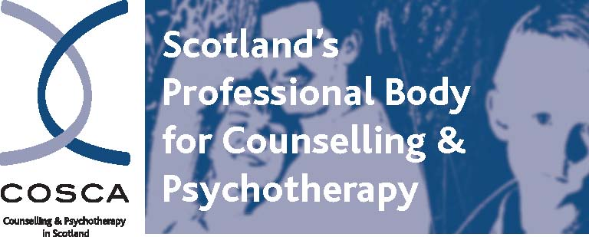

COSCA (Counselling & Psychotherapy in Scotland)
16 Melville Terrace | Stirling | FK8 2NE
t: 01786 475 140 f: 01786 446 207
e: info@cosca.org.uk w: www.cosca.org.uk

Lay Representative on COSCA’s Ethics Committee (Voluntary Position)

COSCA (Counselling & Psychotherapy in Scotland) wishes to appoint a member of the public as a Lay Representative on our Ethics Committee.

As Scotland’s professional body for counselling and psychotherapy, we seek to advance and support all forms of counselling, psychotherapy and the use of counselling skills.

We are looking for a member of the public on a voluntary basis who:

- has a broad interest in counselling and psychotherapy
- is not a counsellor or psychotherapist
- is not a member of COSCA
- does not work for a member organisation
- has good team working skills

The successful applicant will be required to attend meetings of the Ethics Committee, which are held in person or online. COSCA will provide induction support. Claims for previously agreed travel expenses can be submitted for attendance at Committee meetings.

For full details on how to apply and for more information on the role, please see below or under About Us/Vacancies on our website. www.cosca.org.uk. To discuss your interest and/or submit the application form, please contact Brian Magee, Chief Executive. brian@cosca.org.uk

The closing date for applications is noon on Friday 17th November 2023.

COSCA (Counselling & Psychotherapy in Scotland)
16 Melville Terrace | Stirling | FK8 2NE
t: 01786 475 140 f: 01786 446 207
e: info@cosca.org.uk w: www.cosca.org.uk

Lay Representatives Application Briefing Pack

Introduction

Thank you for your interest in being appointed as a Lay Representative onto the Ethics Committee of COSCA (Counselling & Psychotherapy in Scotland). This application briefing pack sets out the information relating to the appointment of a Lay Representative. After reading the information, we hope that you will decide to apply to become a Lay Representative.

Why Become a Lay Representative?

Becoming a Lay Representative provides you with the opportunity to become involved and play an active role in the field of counselling and psychotherapy. This appointment is an important way for you to contribute to the advancement of counselling and psychotherapy in Scotland, improve your contacts and use and develop your skills and experience.

Role of Lay Representative

COSCA Ethics Committee Members, including Lay Representatives, are responsible on a voluntary basis to COSCA’s Board for the development, review and implementation of COSCA’s Statement of Ethics and Code of Practice. This Statement enshrines COSCA’s thinking on the good practice of counsellors and psychotherapists. Working with the Chief Executive, the Committee is also involved in:
- organising and leading our annual ethical event
- assisting with the development of ethical guidelines as required
- the investigation of complaints against members of COSCA.

Requirements:

- not to be a counsellor or psychotherapist, a member of COSCA, or work for a member organisation
- to be able to work in a small team
- to be interested in public protection
- to have had some experience or knowledge of an ethical framework or set of professional standards
- to be able to understand and process ethical dilemmas.
The Ethics Committee usually meets 3 times per annum either in Stirling or online. Meetings are arranged in advance with Committee members and are two hours in length. The Chief Executive provides secretariat for Committee meetings and attends its meetings and events. The meetings are chaired by one of the members of the Committee. In accord with COSCA’s volunteer expenses policy, agreed in advance out-of-pocket expenses can be claimed by members attending meetings and carrying out their roles as Committee members.
Lay Representatives – COSCA Complaints Panellists

Ethics Committee members, including Lay Representatives, also sit on COSCA Complaint Panels in a voluntary capacity. These panels decide on complaints submitted to COSCA about members including counsellors, psychotherapists, supervisors, counselling skills users, students and counselling/counselling skills organisations. No previous experience of working as a complaints panel member is required. Panellists will be obliged to adhere to the principle of confidentiality in carrying out their work. Panellists, working on a voluntary basis and in the interests of public protection, need to be able to:

- objectively examine written evidence in a constructive manner
- conduct interviews and analyse resulting evidence
- make decisions in a group setting based on evidence
- write reports
- be interested in public protection and work in a small team
- value the work done by counsellors and psychotherapists

Conflicts of Interest

Lay Representatives will be required to declare in their application any conflicts of interest and, if appointed, work within the COSCA Conflict of Interest Policy.

Application Process

You are invited to apply to become a Lay Representative by completing and signing the application form included in this Information Pack. Please return your completed application form by email to: brian@cosca.org.uk You can contact Brian Magee, Chief Executive, if you would like to discuss your interest in becoming a Lay Representative: brian@cosca.org.uk

All applications will be acknowledged on receipt. Applicants will be assessed against the above Lay Representative Person Specification criteria. The Chief Executive may invite you to discuss your application.

Further Information

Further information on the work of COSCA (Counselling & Psychotherapy in Scotland) can be found on our website. www.cosca.org.uk

Application Form

The application form can be found on the next page.

Brian Magee
Chief Executive
COSCA (Counselling & Psychotherapy in Scotland)
August 2023
COSCA (Counselling & Psychotherapy in Scotland)
16 Melville Terrace | Stirling | FK8 2NE
t: 01786 475 140 f: 01786 446 207
e: info@cosca.org.uk w: www.cosca.org.uk

COSCA (COUNSELLING & PSYCHOTHERAPY IN SCOTLAND)

LAY REPRESENTATIVE APPOINTMENT ON ETHICS COMMITTEE

APPLICATION FORM

PERSONAL DETAILS

Name:

Address:

Post Code:

Email:

Telephone (Daytime) | Telephone (Evenings)

ELIGIBILITY CHECKLIST

Please tick the boxes below that apply to you.

- I am over 18 years of age
- I have never been convicted of any offence involving dishonesty or deception
- I have not been convicted of a crime and sentenced within the last 5 years
- I have not been subjected to a disciplinary or grievance procedure in the last 5 years
- I have never been made bankrupt nor made a composition with creditors
- I have been made bankrupt (or made a composition with creditors) but was discharged in respect of it on (please enter date) …………..

CONFLICTS OF INTEREST

Please list any potential conflicts of interest that you are aware of.

EXPERIENCE

Have you ever been involved in carrying out the work of an ethics committee or procedures related to professional ethics? If yes, please give details

SUPPORTING STATEMENT

- Please provide a supporting statement, clearly outlining how you meet the requirements of a Lay Representative on COSCA’s Ethics Committee. Please continue on a separate sheet if necessary (maximum 2 pages)

- Please refer to the Lay Representative Job Specification in Application Briefing Pack above and demonstrate how you meet the required criteria.

DECLARATION OF WILLINGNESS TO BE APPOINTED

I declare that the information I have given is true and correct. I am aware that the information given above will be made available to the Chief Executive and others who may be involved in the assessment of the application.

Print Name:
Signature:

Date:

REFERENCES

Please provide us with at names and contact details of at least two referees who are willing to submit a reference in support of your application. Please note that we cannot accept references from family members.

Name of Referee | Name of Referee
Relationship | Relationship
Company/Organisation | Company Organisation
Telephone | Telephone
Email | Email
Address | Address

In completing this form, please refer to the Application Briefing Pack. If you require this form in large font, please contact the COSCA office.

