

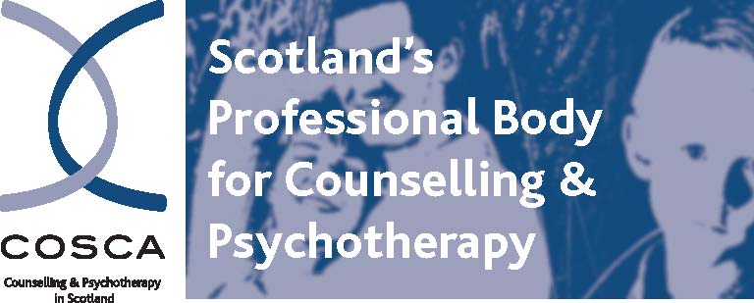

**COSCA (Counselling & Psychotherapy in Scotland)**

**16 Melville Terrace |Stirling | FK8 2NE**

**t: 01786 475 140**

**e:** [**info@cosca.org.uk**](mailto:info@cosca.org.uk) **w :** [**www .cosca.org.uk**](http://www.cosca.org.uk/)

**COSCA Annual General Meeting**

**Wednesday 3rd September 2025 from 2pm - 3.30pm**

**Arrival and Registration - 1.30pm**

**The Barracks Conference Centre, Stirling**

**A G E N D A**

1. Welcome and Apologies
2. Minutes of Annual General Meeting held on 26 September 2024

4 To hear reports of activities during the year

4.1 Report of the Chair: Jan Kerr

4.2 Report of the Chief Executive: Brian Magee

4.3 Report of the Treasurer: Tatjana Hine OBE

5. To present and affirm the Report of the Trustees and Financial Statements for the

Year Ended 31 March 2025

6 To declare that French Duncan LLP trading as AAB, Chartered Accountants, be

re-appointed as Accountants by the Company

7 Board Resignation and Appointments

8 Keynote Presentation: To be confirmed

9 Comments/Questions

10 Close

To register your attendance/apologies for this in-person AGM, please email: [christina@cosca.org.uk](mailto:christina@cosca.org.uk) by Thursday 14 August 2025 with your membership number and email, and any other relevant information.

Thank you for your continued support.

**By Order of the Board**

**Brian Magee, Chief Executive, Registrar and Company Secretary March 2025**

(COSCA reserves the right to amend or change this Agenda.)

Charity Registered in Scotland No. SC018887 Charitable Company Limited by Guarantee Registered in Scotland No. 142360