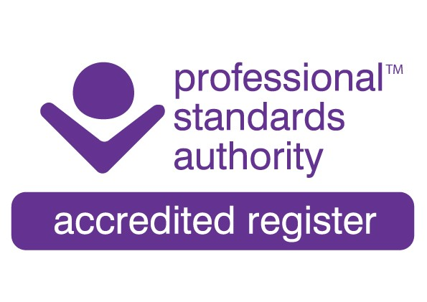
Chair: Jan Kerr
Chief Executive: Brian Magee

COSCA Statement on the Supreme Court judgment on sex as applied in the Equality Act 2010

Last month (April 2025), the UK Supreme Court passed their judgement in the appeal of ‘For Women Scotland Limited against The Scottish Ministers’, ruling that the legal definition of a woman is based on biological sex.

In effect, the Supreme Court unanimously concluded that references in the Equality Act 2010 to “man”, “woman” and “sex” were references to biological sex (meaning “the sex of a person at birth”). The judgment has not changed the law. It has given an authoritative interpretation of the legislation as enacted.

COSCA is aware that the impact of the above ruling on the TGNB (Transgender and Gender Non-Binary) community could be challenging and upsetting. At all times, but especially at this time of change, COSCA lends its support to this community and is committed to ensuring that COSCA members will not discriminate against the TGNB community, or any other community, when delivering services. COSCA will continue to promote the non-discriminatory principles laid down in the COSCA Statement of Ethics and Code of Practice and will encourage its members to work under them and within their own competencies.

The impact of the above judgement on members, clients, trainees, supervisors and professional bodies such as COSCA is still to be fully understood, and this may take some time due to the complexities that have arisen as a result of the above ruling.

In the meantime, COSCA is confident that its individual and organisational members will continue to respect and value each person with whom they work, and will always act in the best interests of, and for, the welfare of their clients, trainees and colleagues, without prejudice to them.

Brian Magee
Chief Executive
COSCA (Counselling & Psychotherapy in Scotland)
May 2025

16 Melville Terrace, Stirling FK8 2NE T: 01786 475 140 F: 01786 446 207 E: info@cosca.org.uk W: www.cosca.org.uk
Charity Registered in Scotland No. SC018887 Charitable Company Limited by Guarantee Registered in Scotland No. 142360
Committed to Equal Opportunities

