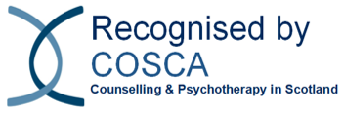
16 Melville Terrace | Stirling | FK8 2NE
t: 01786 475 140 f: 01786 446 207
e: info@cosca.org.uk w: www.cosca.org.uk
Charity Registered in Scotland No. SC018887
Charitable Company Limited by Guarantee Registered in Scotland No. 142360

Recognition Scheme Annual Standards Event

Wednesday 6th August 2025 10:00 to 12:00, over Zoom and just £10

How can we make use of AI in counselling and counselling skills organisations?”

The event is by invitation only, so please request your invitation by Thursday 31st July at the latest to jenna@cosca.org.uk

Name | Date
Email

Organisation | Location

COSCA prefers applicants to make payments direct to the bank. Please give the name of your organisation as a reference when making the payment. Virgin Money. Sort Code: 82 68 05. Account Number: 70174110

