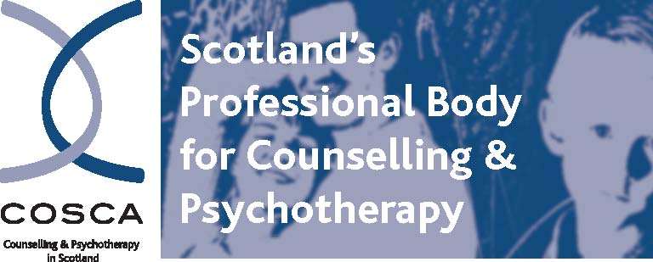
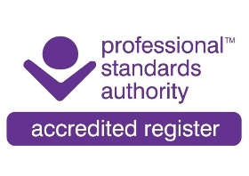
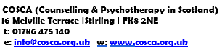

NOTICE AND AGENDA OF GENERAL MEETING

Notice is hereby given that the Annual General Meeting of COSCA
will be held via zoom on Wednesday 30th September 2026 from 11am-1pm.

AGM AGENDA

- Welcome and Apologies

- Minutes of Annual General Meeting held on 3rd September 2025

3 To hear annual reports of activities during the year

3.1 Report of the Chair: Jan Kerr
3.2 Report of the Chief Executive: Brian Magee
3.3 Report of the Interim Treasurer: Carol Smart

4. To present and affirm the Report of the Trustees and Financial Statements for the
Year Ended 31 March 2026

5. To declare that French Duncan LLP trading as AAB, Chartered Accountants, be
re-appointed as Accountants by the Company

6. Board Resignations, Appointments & Retiral of Chair

7. Informal Questions/Comments Session

8. Keynote Presentation: ‘Therapist Incongruence: how self-aware are we?’
Louise Wilson, person-centred therapist, supervisor and trainer

9. Discussion Groups

10. Close

COSCA reserves the right to amend or change this Agenda.

To register your attendance/apologies for this AGM held on zoom, please email: christina@cosca.org.uk by noon on Wednesday 23 September 2026 with your membership number and email, and any other relevant information.

Thank you for your continued support.

By Order of the Board
Brian Magee, Chief Executive, Registrar and Company Secretary August 2026

Charity Registered in Scotland No. SC018887 Charitable Company Limited by Guarantee Registered in Scotland No. 142360

